Eukaryotic Cell Structure
The following structures are associated with eukaryotic cells. In the diagnostic microbiology laboratory, Medically important fungi and parasites have eukaryotic cells.

Cytoplasmic structures
The nucleus of the eukaryotic cell contains the DNA of the cell in the form of discrete chromosomes-structures in the nucleus that carry genetic information (genes)-contained within a nuclear membrane. Chromosomes are covered with basic proteins called histones. The number of chromosomes in the nucleus differs according to the particular organism.
A rounded, setractile body called a nucleolus is also located within the nucleus. The nudeolus is the site of rRNA synthe-sis. The nucleus is bounded by a bilayered lipoprotein nuclear membrane.
The Endoplasmic Reticulum is a system of membranes found throughout the cytoplasm. It occurs in two forms. The "rough" ER is covered with ribosomes and is the site of protein synthe-sis. The ribosomes give the ER the rough appearance, The smooth ER does not have ribosomes on the outer surface of its membrane, hence its smooth appearance. Smooth ER does not synthesize proteins, but it does synthesize phos-pholipids. The major function of the Golgi apparatus or complex is to modify and package proteins and lipids sent to it by the ER.
Eukaryotic ribosomes, where protein synthesis occurs, are SOS in size and dissociate into two subunits: 60S and 40S.
They are attached to the rough ER. Eukaryotic cells contain several membrane-enclosed organelles, Mitochondria are the main site of energy production. They contain DNA and the electron transport system that produces energy in the form of adenosine triphosphate (ATP). Lysosomes contain hydrolytic enzymes for degradation of macromolecules and microorganisms within the cell. Peroxisomes contain protective enzymes that break down hydrogen peroxide and other peroxides generated within the cell. Chloroplasts, found in plant cells, are the sites of photosynthesis. Chloroplasts are the sites where light energy is converted into chemical energy (ATF). Photosynthesis produces oxygen from carbon dioxide and water. Fungi are not plants and have no chloroplasts

Cell Envelope Structures
Plasma membrane
The plasma membrane is a phospholipid bilayer with embedded proteins that envelops the cytoplasm and regulates transport of macromolecules into and out of the cell. A substantial amount of cholesterol is found in the plasma membrane of animals. Cholesterol has a stabilizing effect and helps keep the membrane fluid. The polar heads of the phospholipids are hydrophilic (water loving) and lie on the intracellular and extracellular sides of the membrane; their nopolar tails are hydrophobic (water hating) and avoid water by lining up in the center of the plasma membrane "tail to tail." This type of hydrophobic makeup of the interior of the plasma membrane makes it potentially impermeable to water-soluble molecules. Proteins, embedded in the mem-brane, perform several important functions. They can act as enzymes, hormone receptors, pore channels, and carriers.
Cell wall
The function of a cell wall is to provide rigidity and strength to the exterior of the cell. Most eukaryotic cells do not have cell walls. However, fungi have cell walls principally made of polysaccharides, such as chitin, mannan, and glucan. Chitin is a distinct component of fungal cell walls.
Motility organelles
Cilia are short projections (3 to 10um), usually numerous, that extend from the cell surface and are used for locomotion. They are found in certain protozoa and in ciliated epithelial cells of the respiratory tract. Flagella are longer projections (>150 um) used for locomotion by protozoa and animal cells such as spermatozoa.

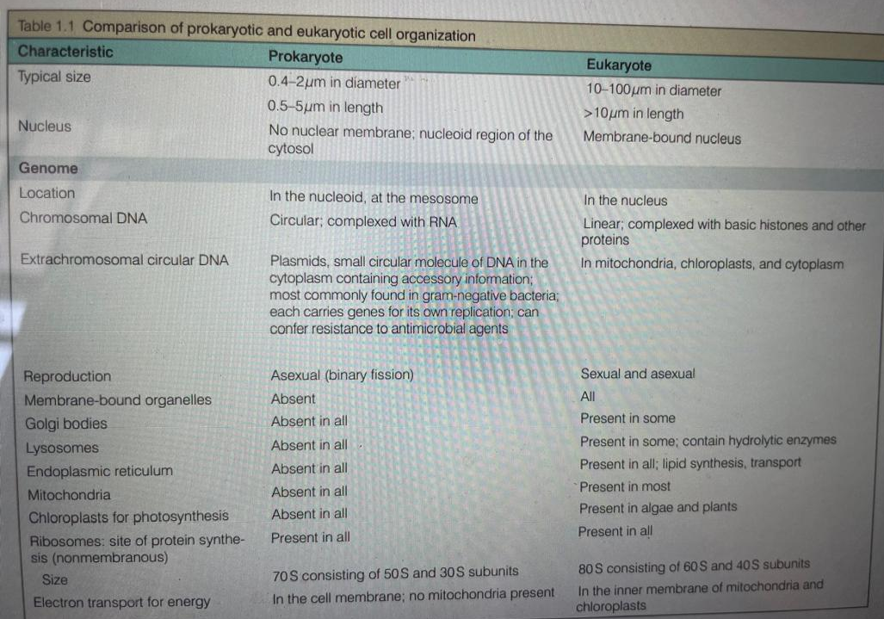

Comparison of Prokaryotic and Eukaryotic Cell Organization.

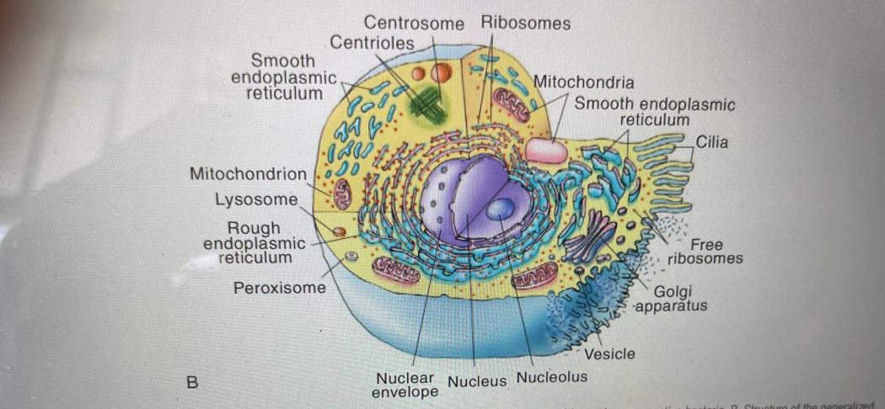

An Eukaryotic Cell

Viruses
Viruses are the smallest infectious particles and cannot be seen under an ordinary light microscope, can be seen with the electron microscope. Often, we can see their effects on cell lines grown in the laboratory, such as inclusions, rounding up of cells, and syncytium (fusion of host cells into multinucleated infected forms), where these characteristics become diagnostic for many viral diseases. These visible changes are called cytopathic effect. Viruses are acellular (not composed of cells) and are therefore neither prokaryotic nor eukaryotic. They are distinguished from living cells by the following characteristics:

• Viruses consist of deoxyribonucleic acid (DNA) or ribonucleic acid (RNA), but rarely both. Their genome can be double-stranded DNA (dsDNA), single-stranded DNA (ssDNA), double-stranded RNA (dsRNA), or single-stranded RNA (ssRNA).
• Viruses lack cytoplasmic membranes and are surrounded by a protein coat.
• Viruses are obligate intracellular parasites that cannot self-replicate. They require host cells for replication (increase in number does not involve mitosis, meiosis, or binary fission) and metabolism. Because they lack ribosomes and other metabolites, they "take over" host cell function using the host cell machinery to reproduce. Growth (increase in size) does not occur in Viruses.

Viruses are mostly host or host cell specific. For example human immunodeficiency virus infects T-helper lymphocytes, not muscle cells, in humans, whereas other viruses such as the rabies virus, can infect dogs, skunks, bats humans, and other animals. A virus that infects and possibly destroys bacterial cells is known as a bacteriophage (Greek phage: to eat). Viruses are classified and identified by their genome (DNA or RNA), host range, host disease sign and symptoms, chemical makeup, geographic distribution the presence or absence of an envelope, their resistance to changes in pH and temperature, their antigenicity (serologic methods), how the virus replicates, and the virion (a complete virus outside a cell) size.

For simplicity purposes, many texts limit viral classification to three basic properties: (1) viral morphology; (2) method of replication, including genome organization (whether the genome is RNA or DNA and single- or double-stranded); and (3) presence or absence of a lipid envelope. The phrase “means of replication” refers to the strategy the virus uses to duplicate the viral genome. For example, enteroviruses have single-stranded RNA genomes that synthesize additional strands of RNA, whereas retroviruses make RNA molecules in a two-step process by first synthesizing DNA, which subsequently is converted to RNA. Examples of Viruses include Rotavirus, Hepatitis A, B, C, D, E Viruses, HIV, Human Papilloma Virus (HPV), Herpes Simplex Virus (HSV), Influenza Virus, Corona Virus, Lassa Virus, Cytomegalovirus etc.
ASSESSMENT: Based on the three basic properties mentioned above, classify the aforementioned Viruses.
E.g Rotavirus - Icosahedral, double stranded RNA, non-enveloped.

